**DU LOCATOR**

**NITIN JANGID**

**JUNE 2018**

**Abstract**

DU Locator is an all-inclusive Web application designed for students who are seeking admission in Delhi University. This web-site showcases information about the latest as well as previous year cut-offs of colleges and departments under DU which might be helpful for students in deciding their imminent college. It also has information about the Lively spots, nearby metro-stations and all the updates about the happening events of DU.

**1. Motivation**

To make a Web application which will serve as a complete package for someone seeking admission in DU or is already a part of DU. The website should include all features from latest cut-offs, information about Lively spots and public transport facilities, to updates about the various events happening in Delhi University, Also there is open form in which user can ask his/her query but for that authentication is required.

I was Interning at Excel IT Services as a full Stack Engineer. As Excel IT Services takes many interns for contributing in Real Projects, this web Sites will also enable Authentication and by using this user able to add Comments in specific page of College.

**2. Problem statement**

Every year thousands of students seek admission to the Delhi University. Based on the admission application when the cut-offs are released, a lot of problem is created due to huge traffic many time official website crashes. This creates a big problem because the time interval between cutoff’s are very less .

Many students of Delhi University who are not from Delhi or nearby areas faces several problems like not knowing

* Availability of public transport
* Nearby recreational spots etc.
* Any personal query which cannot be solved on official website.

There is no handy source to get information about the events happening in various colleges of DU.

The project is mainly focused on providing the solutions to such problems.

**3. Method**

Before getting into the project my first goal was to learn about the technology that company uses and to understand the various components that would be required to develop the application.

As our instructor direct us what to do, firstly I learn about it and then implement on the same day.

We were provided the data for particular colleges like address, photos Google API’s for location Services.

Based on data we decided to work on NODE JS rather than PHP because Node.js is well suited for applications that have a lot of concurrent connections and each request only needs very few CPU cycles, which make our website load faster.

We were asked to work on online Cloud 9 IDE which is very popular now a day, due to anyone else can contribute in your project.

As a better way to develop the application was determined by developing the application in **small chunks**, testing them and once meet they meet the specified standard, then only implementing the logic in the main application. This method enabled me to save development time as **I only had to debug a small block of code at a given time rather than debugging the whole application at the same time.**

We mainly use NPM package manager for Node Js which provide a lot of libraries to work on.

This way for formatting also allows the for safe update for information in the future.

Excel IT Services is a client-based company, it was our job not to let affect company’s relation that why whatever we asked to do we focuses on that only.

While Authentication we mainly focus on not to store user personal information in company’s database, our main goal was ensuring security of Colleges Data Information means not to made any transformation so that users have to suffer.

While making this web-site main goal was to make this run well even after getting a lot of traffic which is not present on Du Official Website.

No data manipulation will be allowed inside the application in Comment Side. To update the data in Mongo Server, we must get permission from our authority. This also ensures the safety and speed of data These enables people to get access to the colleges thumbnail fastly, they require and no more than that maintaining the integrity and safety of the data.

A Brief overview to our application:

A close up of text on a white background

Description generated with very high confidence

A close up of text on a white background

Description generated with very high confidence

We have used most router techniques (GET, POST, Push, Delete) which help us to make our website multipage and responsive and helped to make our code clean.

**4. Analysis and Results**

The application displays the cut-off lists of different years for different streams and different categories.

* When user opens the website an animated parallax imaging appears with the set of Images.
* Application displays public transportation and recreational spots which are there within a certain range of college. For this we have used Google Maps API.
* Information about a college is also retrieved from the database using Mongo DB queries.
* Admin can add an event update or feed to the application by adding the feed to the database by using MySQL queries. The application checks for any new event update every 1 hour and pushes a notification on website itself if there is any new feed.
* The most recent cut-off list is displayed first (this is our main goal ).

The following figures show the result when the application runs-

A person sitting on display in front of a computer screen

Description generated with high confidence

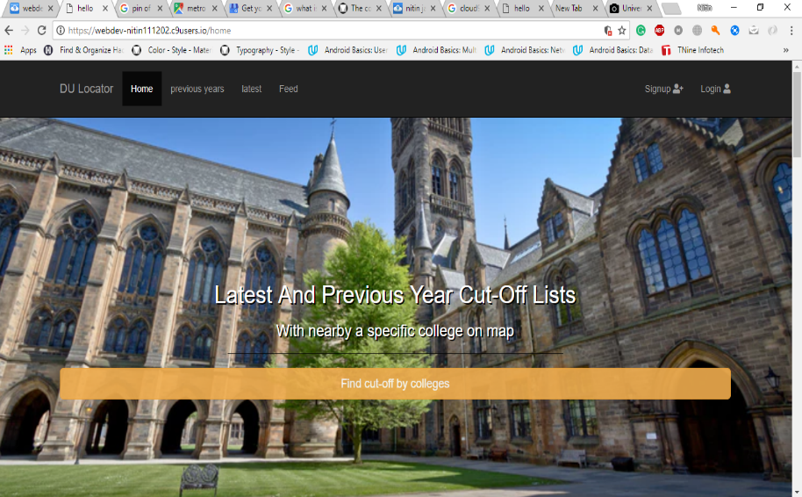

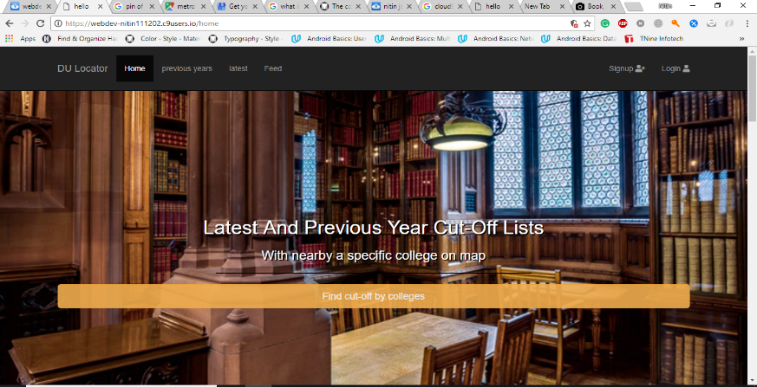

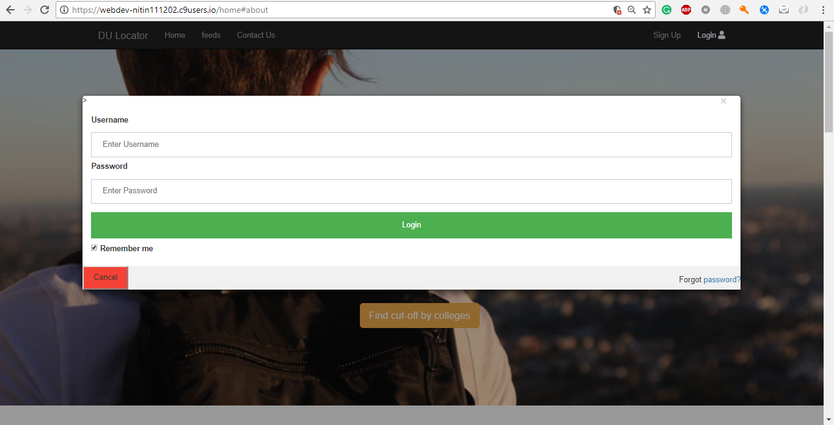



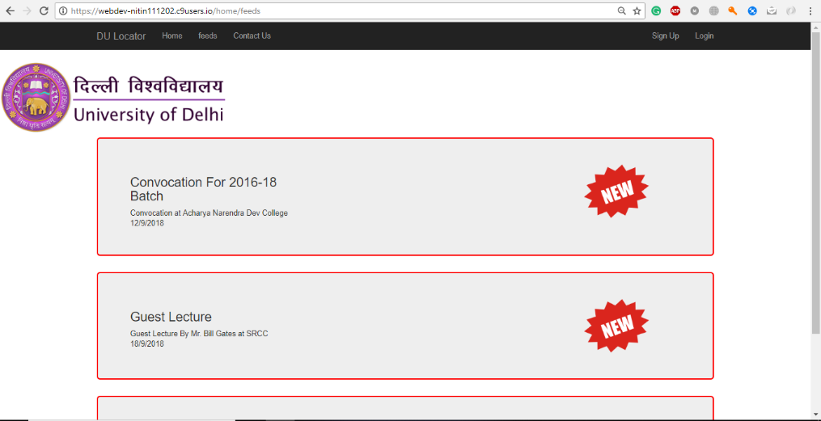

**A screenshot of a social media post

Description generated with very high confidence**

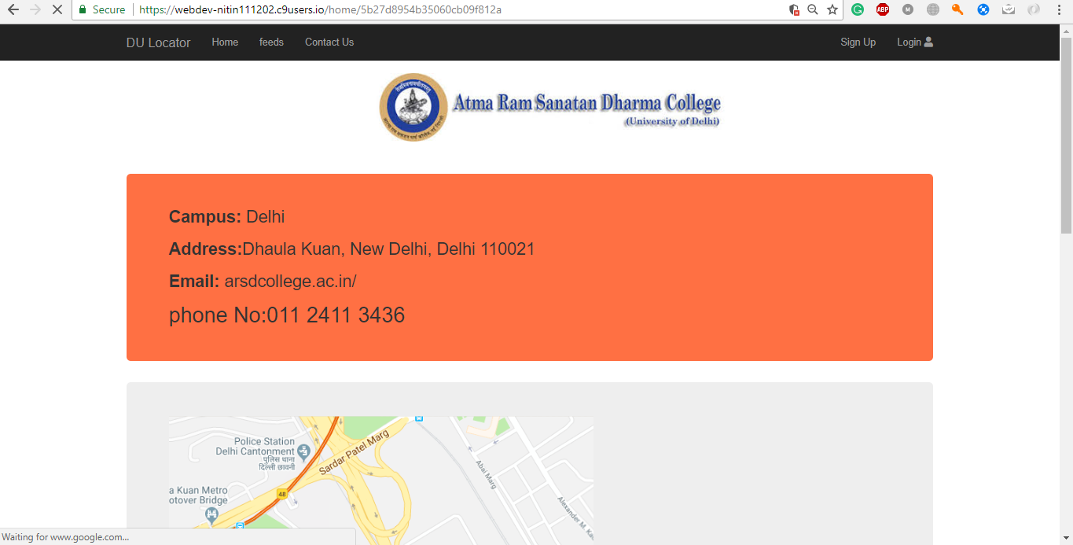

**A screenshot of a cell phone

Description generated with very high confidence**

*Screenshot: Comment Form*

**5. Related work**

The related work included of designing using bootstrap and DOM. The meta data provided by company of Du colleges make that data understandable using Php.

Buying Domain, giving update to client regarding completion.

**6. Conclusion**

This shows the end of my synopsis stating the clear need for the application, the use case along with the basic ideas and techniques that would be used to create and test the application to ensure that the application meets the desired specifications laid down by my mentor and to ensure that the application works as desired.

**References**

1. <https://www.w3schools.com/>
2. <https://www.w3schools.com/nodejs/default.asp>
3. <https://www.w3schools.com/nodejs/nodejs_http.asp>
4. <https://www.w3schools.com/nodejs/nodejs_npm.asp>
5. <https://www.npmjs.com/>
6. <https://community.c9.io/t/setting-up-mongodb/1717>
7. <https://jira.mongodb.org/browse/DOCS-6882>
8. <https://docs.mongodb.com/manual/tutorial/install-mongodb-on-ubuntu/#install-mongodb>
9. <https://stackoverflow.com/questions/5813771/in-ejs-template-engine-how-do-i-include-a-footer>
10. <https://docs.npmjs.com/getting-started/installing-npm-packages-locally>
11. <https://docs.npmjs.com/getting-started/using-two-factor-authentication>
12. <https://docs.npmjs.com/getting-started/fixing-npm-permissions>

**MARK STATEMENT FOR PS-II MIDSEM ASSESSMENT**

**(To be filled by faculty Mentor)**

|  |  |  |  |  |  |
| --- | --- | --- | --- | --- | --- |
| **Component** | **Maximum**  **Marks** | **Excellent**  **(5 Marks)** | **Good**  **(4 Marks)** | **Pass**  **(2 mark)** | **Marks Awarded** |
| **Project Title** | **5 Marks** | Clear and gives complete information of the nature of work | Generic in nature | Not clear |  |
| **Aims and objectives of the project/ Problem Statement**  **(From Synopsis)** | **5 Marks** | * All requirements and objectives are identified, clear and possible to execute within the time frame * Problem was adequately framed and relevant to his company | * Problem statement is vague and generic in nature | * Many requirements and objectives are not identified * Not identified any specific problem |  |
| **Preliminary study**  **(From Sunopsis)** | **5 Marks** | Demonstrated evidence of preliminary research effort and a depth of thinking about the topic. | Demonstrated evidence of limited research effort and/or initial of thinking about the topic | Did not demonstrate knowledge of the course content, evidence of the research effort or depth of thinking about the topic. |  |
| **Methods and expected Analysis**  **(From Synopsis)** | **5 Marks** | The deliverable may offer new information or approach to the topic under discussion. | The deliverable may offer some new information or approach to the topic under discussion. | The deliverable offers no new information or approach to the topic under discussion |  |
| **TOTAL OUT OF 20** | | | | |  |

**** ***To be submitted to Program Office after First Visit along with Project Title Confirmation Form***\*\*\*

|  |  |
| --- | --- |
| **Name of Student** | Nitin Jangid |
| **Branch** | CSC |
| **Faculty Name** | MS Poonam Sangwan |
| **Faculty Signature** |  |